

**University Putra Malaysia**

**Faculty of Computer science and Information Technology**

**Database Application Development SSK3408**

**Web Application project**

**Report on**

**Meal putra food ordering system**

**Project Members:**

**Maharaz Mujtaba Karaye**

**Lecturer: Dr. Ng Keng Yap**

ABSTRACT

**Meal putra food ordering system** is a website system designed primarily for the Universiti Putra Malaysia Students. This system will allow student to order their meal at any time and the order will be delivered in short period of time. The system also allows to quickly and easily ordering which s can browse and use to place orders with just few clicks.

With the increasing popularity of food delivery in colleges and universities, the traditional telephone order food has inconvenience to the customers and the food delivery. How to make the food-delivery more quickly and conveniently has become a concern of many college students. So this report explores and develops new takeaway apps that are easier and more object-oriented than existing apps. Food-delivery app has easy and simple features, but now the food-delivery app is no more convenient for students or working staff, the overall is relatively old, not novel enough, cannot attract new users.

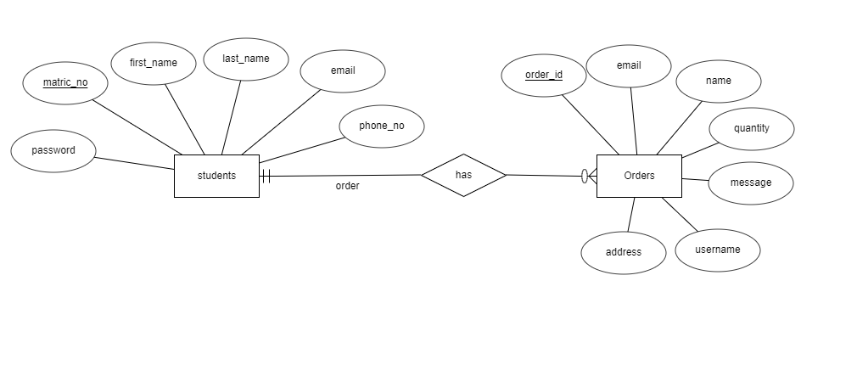

ER Diagram

Results/ Interface

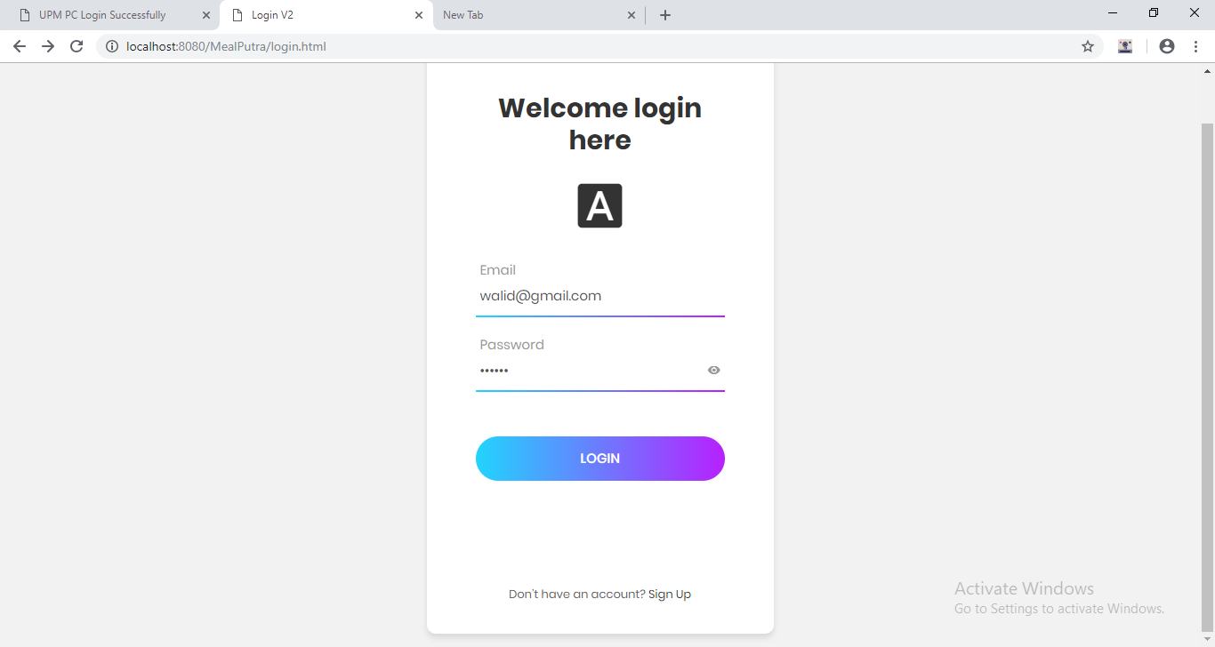

Login

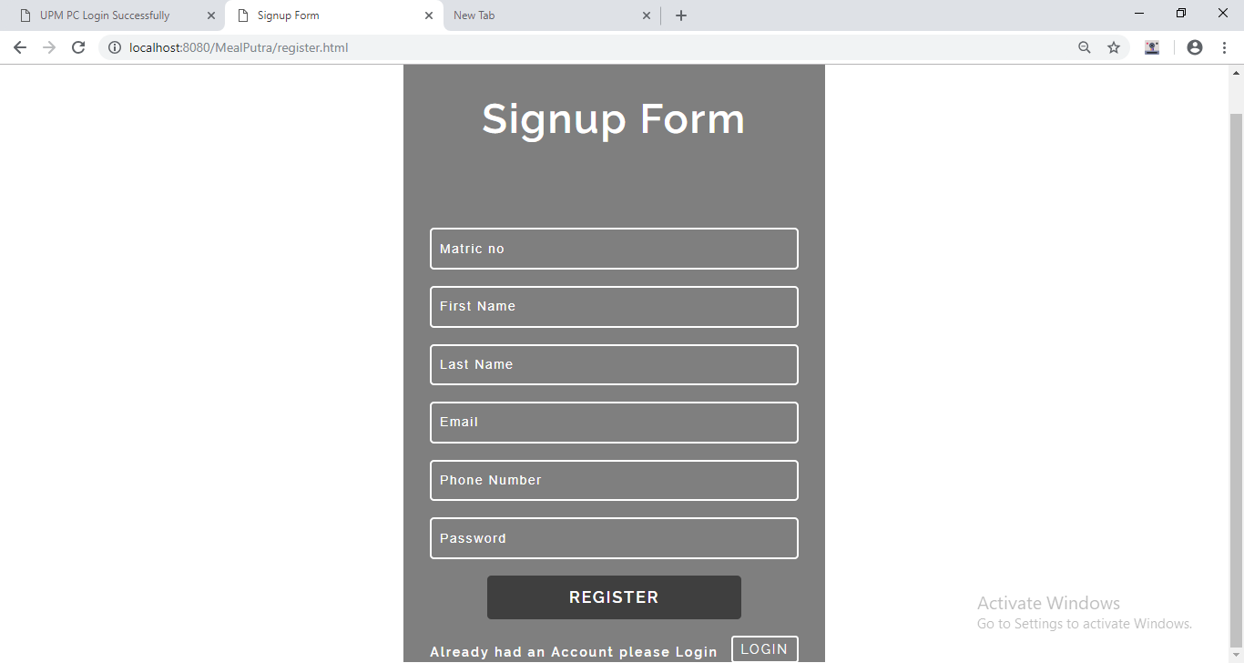

Registration form

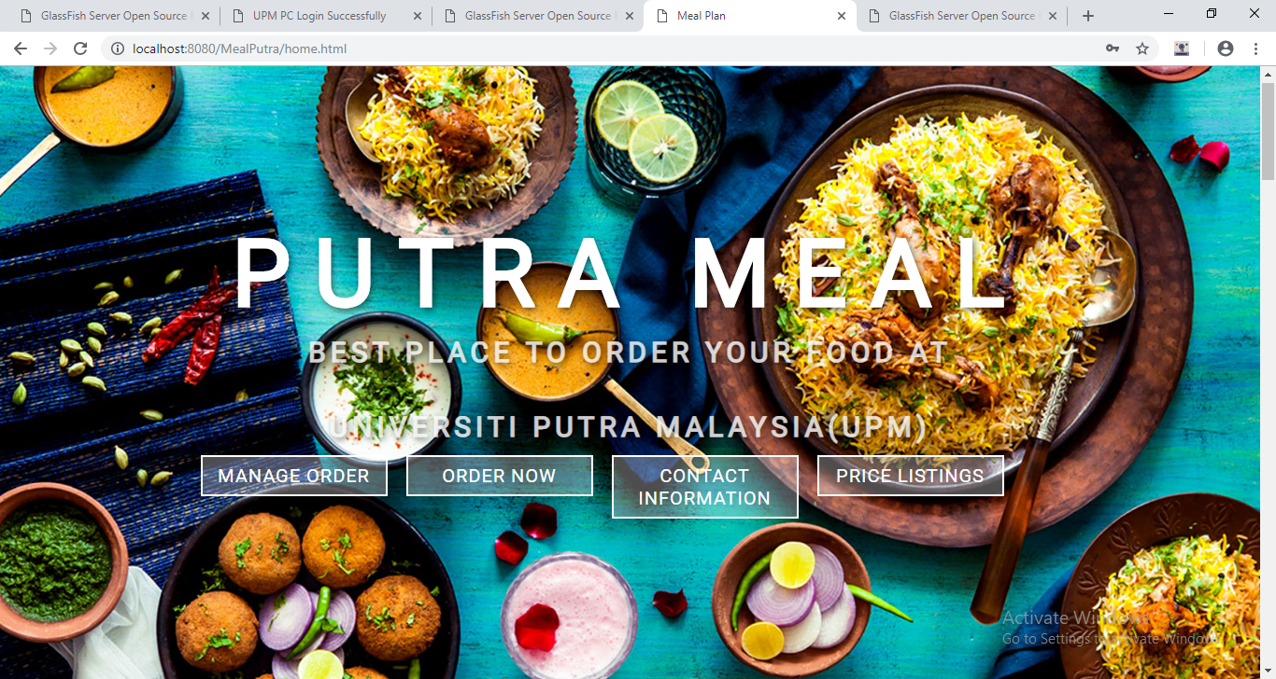

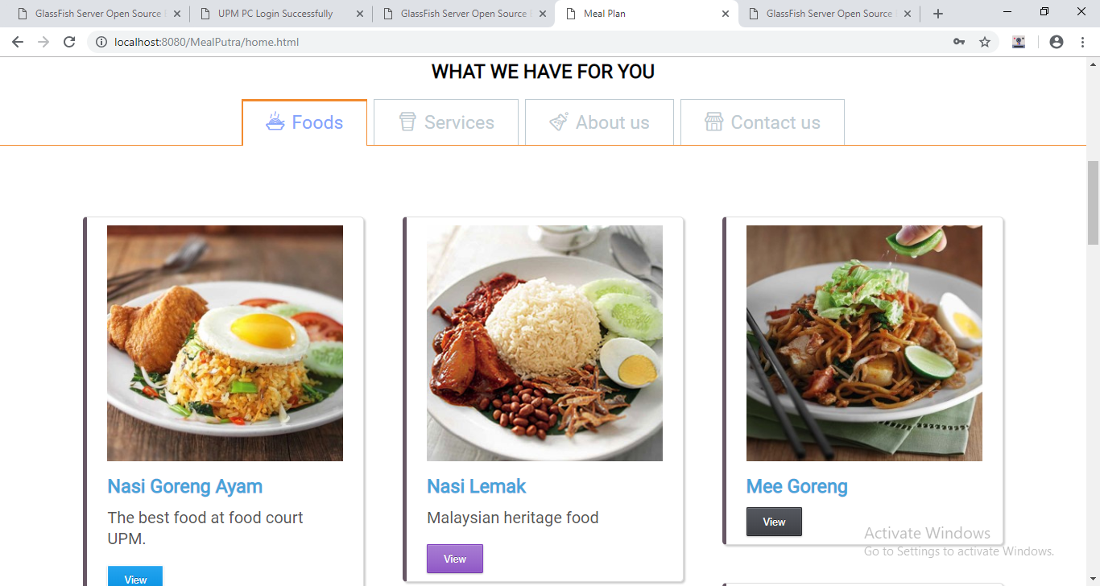

Foods

Services

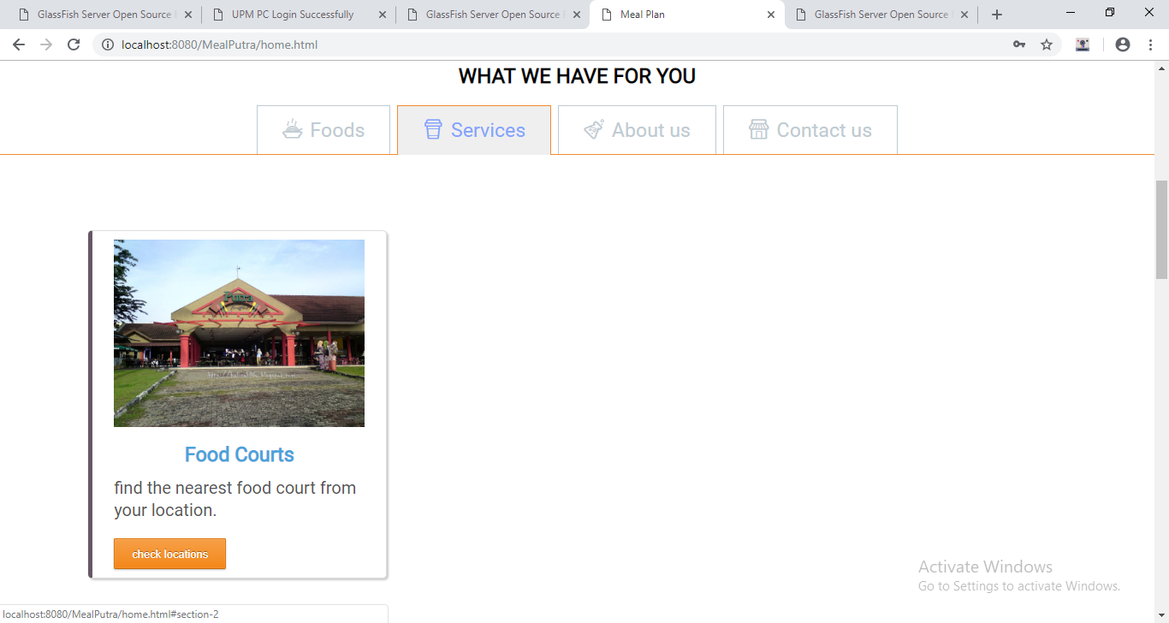

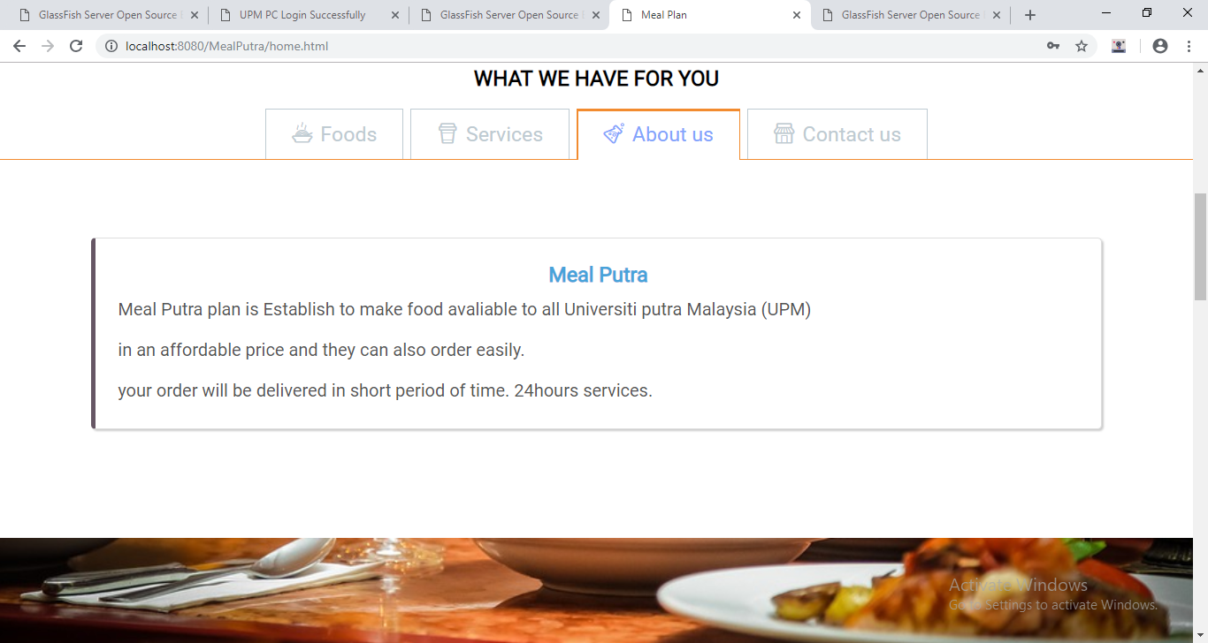

About us

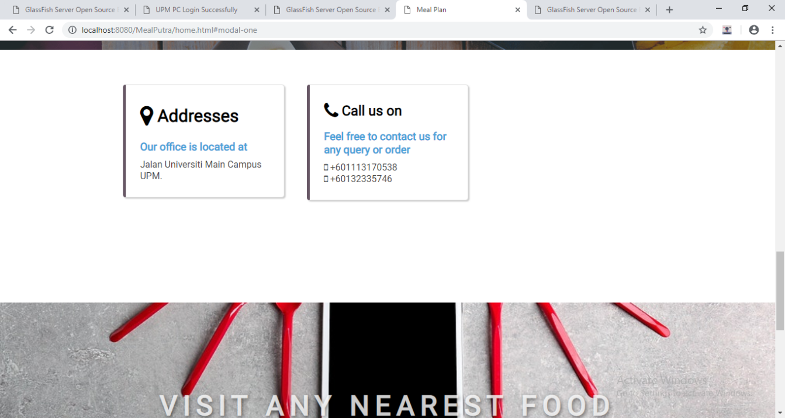

Contact us

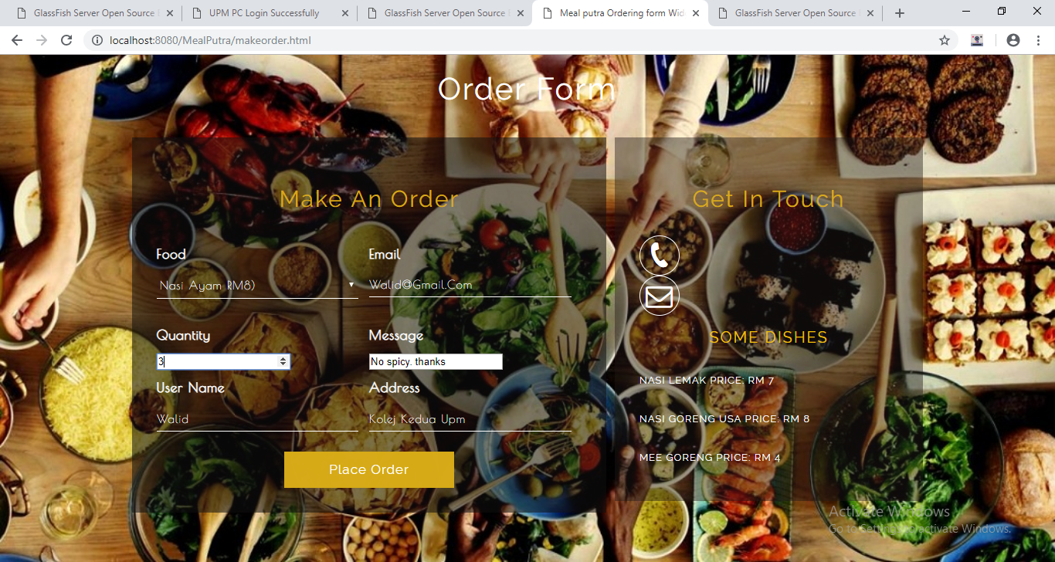

Order form

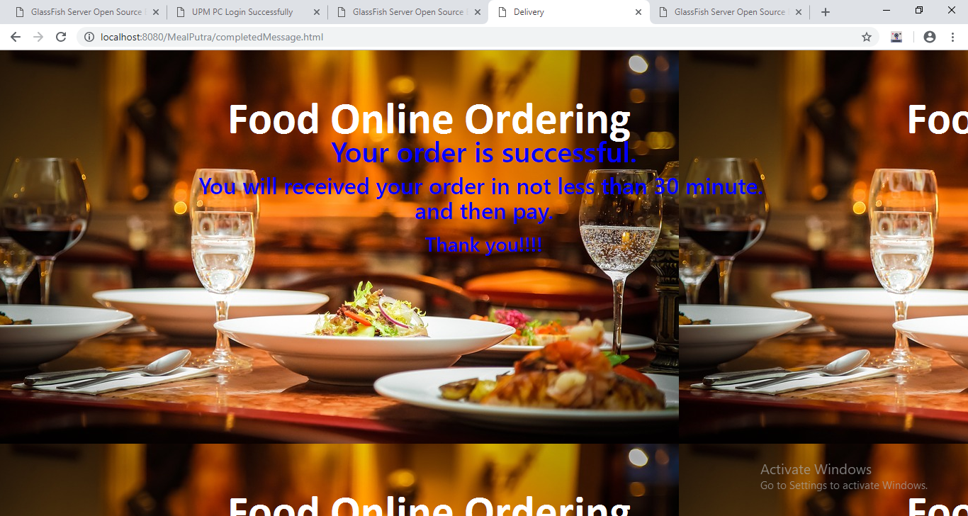

Order successful

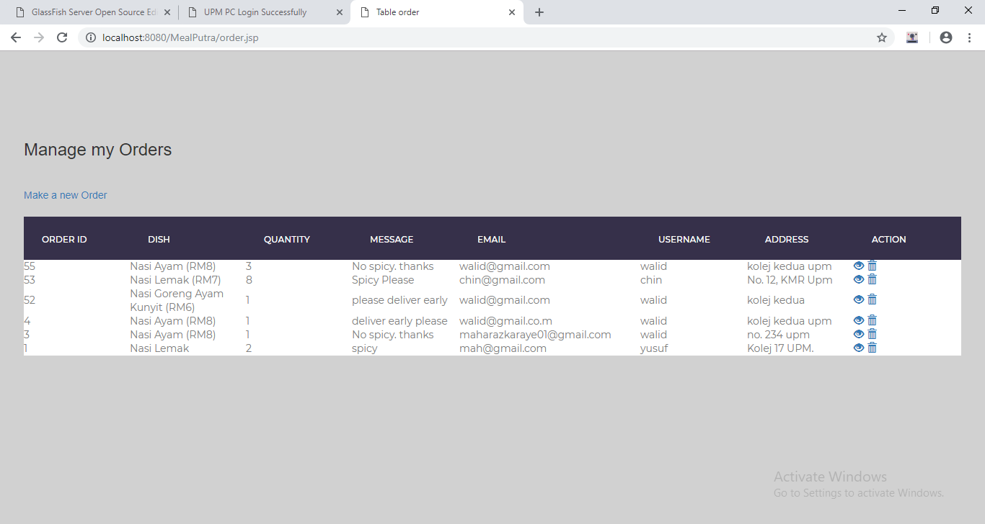

Manage order

REFERENCES

* <https://www.w3layouts.com>
* <https://www.w3school.com>